1. 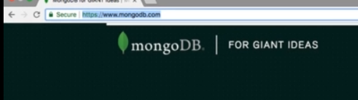
2. The official mongodb site is the best way to learn about more options to configure.
3. **Command**:
4. Command🡺To change port.
5. Command🡺
6. 